How to restore database
How to Restore Database
Step1:
- Copy backup file and paste in your system(means paste in any drives(D:/,E:/...))
Step2:
- Open SQL Server Management studio.
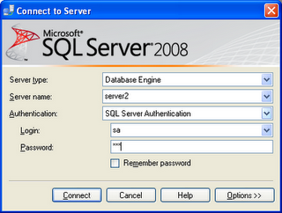

- Go to Object Explorer(It is located at left side) in SQL Server IDE .
- Select "Database" and Right click.
- One window open, in that window select "Restore Databases.." Option.

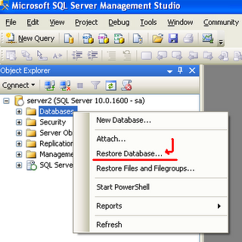
- One window open.
- In that window Having...
- "Todatabase" option, you can give any Database name.
- And select "From Device" radio button. and go to brows... and select "backup file".
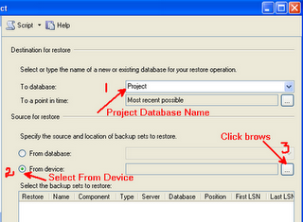

- Specify Backup window in that window click "Add" button.
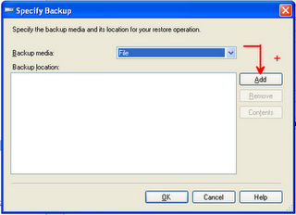

- Drives window displays, select your back up file from your system drives.
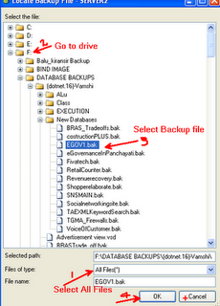

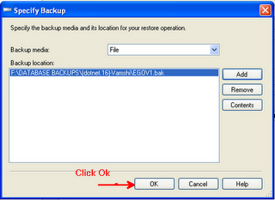

- Click OK button.
- one WIndow display, in that window..
- Check "Restore" check box.
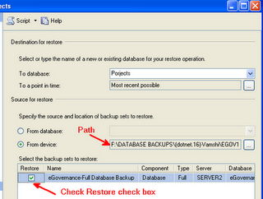

- Click "OK" button.
- MSQLMS window displayed.
- And Click Ok.
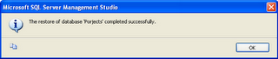

- Database is created with the name is "Project".
- After completing all process.
- Again go to "object explores" and press "Refresh" button.
- Go to database option and expand database.
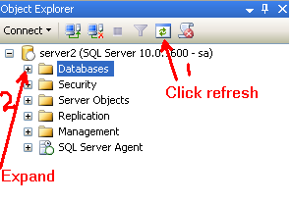

- "Project" is our database name
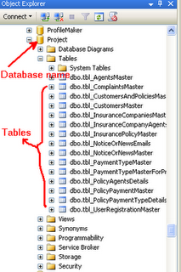

How to run application
- First copy "source code" and paste in your system drive(D:\ or E:\ ,,,)
- Open Microsoft Visual Studio 2008(3.5)/2010.
- VSIDE open.
- In that IDE, go to file menu and select "file" and click.
- select "Open" .
- select "website".
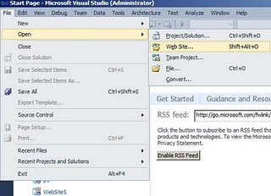

- One window display, in that widow having all your system drives,go to source code and click open.
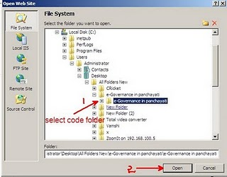

- Next go to "solution explore".
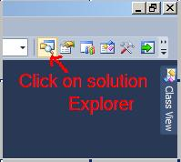

- Solution explore open,go to "web.config" file and double click on web.config.
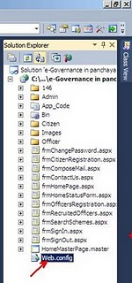

- Web.config file is open,in that go to connection string tag and change
<connectionStrings>
<add name="sqlcon"
connectionString="
Data Source=SERVER2; //server name or your system name
Initial Catalog=eGovernance;//Databse name
User ID=sa;
Password=123"/>
</connectionStrings>
- After changing connection string, save the web.config file.
- Next go to frmHome.aspx/Default.aspx and right click on frmHome.aspx/Default.aspx.
- one window display in that select "Set as start page..".
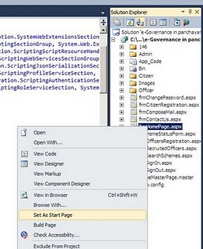
- And run the application.
